Liechtenstein
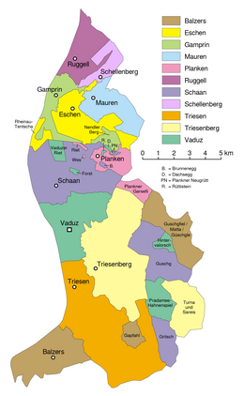
Chronology
15 AD - 493 Part of the Roman Empire (part of Raetia).
493 - 537 Under rule by the Ostrogoths.
537 - 916 Under Frankish rule.
916 - 103. Part of Swabia.
103. - 8 Nov 1260 Part of Unterrätien (Vorarlberg).
8 Nov 1260 - 3 May 1342 Part of Sargans.
3 May 1342 Vaduz (Vadutz) separated from Sargans in a dynastic
division, and upon imperial ratification on
22 Jul 1396, Vaduz is formally recognized as
immediate (reichsunmittelbar).
1396 Vaduz pawned by the Count to his step-brothers
for 24 Marks of silver with interest.
1404 Schellenberg pawned by the ruler of Vaduz to his
step-brothers (renewed 1409).
21 Jul 1405 The people of Schellenberg allied themselves with
the Swiss (Sankt Gallen and Appenzell) against
their lords during the Appenzell Wars.
15 Sep 1405 Feldkirch (in Vorarlberg) joins Schellenberg in
the alliance to form Bund ob dem See (Alliance
above the Lake [Constance]).
4 Apr 1408 Bund ob dem See dissolved by treaty.
6 Sep 1416 Vaduz inherited by the Lord of Brandis.
26 Dec 1430 Blutgerichtsbarkeit (high justice) granted to the
Lord of Brandis for his countship and lordships
in Walgau, Vaduz and in Eschnerberg (subsequently
confirmed 4 Feb 1454, 16 Oct 1492 & 2 Aug 1507).
14 Nov 1437 Maienfeld (in Graubünden, Switzerland) is acquired
from the Count of Toggenburg (effected 4 Sep
1438 by take-over).
4 Mar 1466 Werdenberg-Sargans claims on Lordship and County
of Vaduz waived for a 4,000 Florins payment.
12 Feb 1499 Occupied by Switzerland, lord is captured.
18 Feb 1499 - 13 Dec 1499 Vaduz annexed by the Swiss Confederation.
28 Mar 1509 Lordship of Maienfeld (Mayennfeldt) sold to
Graubünden for 20,000 Florins (effected on 29 Mar
1509 by take-over).
14 Jul 1510 Vaduz sold to nephew for 12,000 Florins by treaty.
22 Mar 1613 Vaduz sold to the Count of Sulz for 200,000 Florins
(effective on 15 Apr 1613).
12 May 1681 Prince-Abbot of Kempten named imperial commissioner
to examine local witch-hunt trials (which are
deemed illegal without exception on 15 Oct 1682).
24 Mar 1684 - 18 Feb 1686 Count is arrested and the county put under Imperial
administration.
Feb 1693 - 9 Jun 1712 Imperial administration.
18 Jan 1699 Lordship of Schellenberg sold to the Prince of
Liechtenstein for 115,000 Florins (effected 16
Mar 1699).
22 Feb 1712 Free Imperial County and Lordship of Vaduz (Freie
Reichsgraf-und Herrschaft Vaduz) purchased by
the Liechtenstein family for 290,000 Florins.
16 Jun 1712 Inherited by minor relatives over senior familias.
9 Dec 1712 Liechtenstein gets a seat in the Reichsfürstenrat
(Imperial Council) ad personam (effective 15 Feb
1713; made hereditary 13 Aug 1723).
12 Mar 1718 Liechtenstein transferred to the respective
"Governor of the House" (Regierer des Hauses)
(senior familias), in exchange for some mediate
possessions (effected 5 Sep 1718).
23 Jan 1719¹ Vaduz and Schellenberg are merged as Principality
of Liechtenstein (Fürstentum Liechtenstein).
6 Mar 1799 - 25 Mar 1799 French occupation.
25 Jul 1806 - 7 Dec 1813 Member of the Confederation of the Rhine.
8 Jun 1815 - 24 Aug 1866 Member of the German Confederation.
1 Aug 1842 Eventual cognatic succession introduced.
30 Mar 1938 Franz Josef II chooses to reside in Vaduz,
subsequently becomes the first prince resident
in Liechtenstein.
24 Mar 1939 Planned 'invasion' by Nazi SA from Germany is
prevented by Vorarlberg state intervention; coup
attempt led by Theodor Schädler (b. 1896 - d.
1975) of VDBL consequently fails.
21 Jun 1945 Liechtenstein family possessions in Czechoslovakia
confiscated as German property (effected on
23 Jun 1945).
Counts of Werdenberg (called of Sargans) and (from 1390/95) Lords of Vaduz (in Vaduz)
(title Graf von Werdenberg, genannt von Sargans, [1390/5] Herr ze Vadutz)
3 May 1342 - 27 Aug 1354 Hartmann (Hartman) I (b. 1305? - d. 1354)
27 Aug 1354 - 6 Sep 1416 Hartmann (Hartman) II (b. 1343? - d. 1416)
- jointly with following two -
27 Aug 1354 - 1 Nov 1367 Rudolf (b. 1344? - d. 1367)
27 Aug 1354 - 26 Jan 1397 Heinrich (Hainrich) (b. 1345? - d. 1397)
27 Aug 1354 - 1363 Rudolf IV Graf von Werdenberg (b. c.1310 - d. 1363)
und Sargans -Regent
1396 - 6 Sep 1416 Wolfhart (Wolffhart) von Brandis (b. 134. - d. 1418)
"der Ältere" (acting)
1396 - 1408 Ulrich Türing von Brandis (acting) (b. 135. - d. 1408)
Lords of Brandis (in Vaduz)
(title Freiherr von Brandis)
6 Sep 1416 - 1418 Wolfhart (Wolffhart) I (s.a.)
1418 - 1459 Wolfhart (Wolffhart) II (b. 138. - d. 1459?)
"der Ältere"
1459 - 9 Oct 1477 Wolfhart (Wolffhart) III (b. 140. - d. 1477)
- jointly with following two -
1459 - 1492 Sigmund I "der Ältere" (b. 142. - d. 1492?)
1459 - 20 Aug 1486 Ulrich (b. 143. - d. 1486)
20 Aug 1486 - 12 Feb 1499 Ludwig (1st time) (b. 144. - d. 1507)
- jointly with following two -
20 Aug 1486 - 12 Feb 1499 Sigmund II "der Jüngere" (1st time)(b. 145. - d. 1507)
20 Aug 1486 - 12 Feb 1499 Johann (Johanns) (1st time) (b. 1456 - d. 1512)
12 Feb 1499 - 13 Dec 1499 annexed by Swiss Confederation
13 Dec 1499 - Jun? 1506 Ludwig (2nd time) (s.a.)
- jointly with following two -
13 Dec 1499 - 18 Nov 1507 Sigmund II "der Jüngere" (2nd time)(s.a.)
13 Dec 1499 - 14 Jul 1510 Johann (Johanns) (2nd time) (s.a.)
Counts of Sulz, Landgraves in Klettgau (in Vaduz)
(title Graf zu Sulz, Landgraf im Klettgau)
18 Nov 1507 - 5 Oct 1535 Rudolf (Rudolff) I (b. c.1478 - d. 1535)
5 Oct 1535 - Dec? 1544 Johann Ludwig (b. 150. - d. 1544)
Dec? 1544 - 1560 Wilhelm (b. c.1524 - d. 1565)
- jointly with following two -
Dec? 1544 - 1552 Rudolff (Rudolf) II (b. 1525? - d. 1552)
Dec? 1544 - 4 Jan 1572 Alwig (Albigk) (b. 1527? - d. 1572)
4 Jan 1572 - 1583 Rudolf (Rudolff) III (b. 1559 - d. 1620)
- jointly with following -
4 Jan 1572 - 15 Apr 1613 Karl (Carol) Ludwig (b. 1560 - d. 1616)
4 Jan 1572 - 14 Nov 1572 Barbara Gräfin von (b. 1534 - d. 1573)
Helfenstein (f) -Regent
14 Nov 1572 - 1580 Regents
- Georg Graf von Helfenstein (b. 1518 - d. 1573)
(to 17 Nov 1573)
- Heinrich Graf zu Fürstenberg (b. 1536 - d. 1596)
Counts of Hohenems (Hochenembs), Gallara and Vaduz² (in Vaduz)
15 Apr 1613 - 10 Sep 1640 Kaspar Graf zu Hohenembs (Hohenems)(b. 1573 - d. 1640)
10 Sep 1640 - 10 Apr 1646 Jakob (Jacob) Hannibal II (b. 1595 - d. 1646)
10 Apr 1646 - 1655 Karl Friedrich (b. 1622 - d. 1675)
- jointly with following -
10 Apr 1646 - 19 Sep 1662 Franz Wilhelm I (b. 1628 - d. 1662)
19 Sep 1662 - 18 Feb 1686 Ferdinand Karl (b. 1650 - d. 1686)
19 Sep 1662 - 20 Oct 1675 Regents
- Eleonora Katharina Gräfin zu (b. 1630 - d. 1670)
Fürstenberg (f)(to 18 Feb 1670)
- Karl Friedrich Graf zu Hohenembs (b. 1622 - d. 1675)
Imperial Commissioner
27 Mar 1684 - 18 Feb 1686 Rupert Fürst und Abt zu Kempten (b. 1646 - d. 1728)
(= Rupert von Bodman) (1st time)
Count of Hohenems (Hochenembs), Gallara and Vaduz (in Vaduz)
18 Feb 1686 - 9 Jun 1712 Jakob (Jacob) Hannibal III (b. 1653 - d. 1730)
Imperial Commissioner
Feb 1693 - 9 Jun 1712 Rupert, Fürst und Abt zu Kempten (s.a.)
(2nd time)
Princes²
16 Mar 1699 - 16 Jun 1712 Johann Adam Andreas (b. 1662 - d. 1712)
16 Jun 1712 - 5 Sep 1718 Joseph Wenzel (b. 1696 - d. 1772)
16 Jun 1712 - Jan 1718 Regents
- Walter Fürst von Dietrichstein (b. 1664 - d. 1738)
- Maximilian Ulrich Graf von (b. 1679 - d. 1746)
Kaunitz und Rittberg
5 Sep 1718 - 23 Jan 1719 Anton Florian (b. 1656 - d. 1721)
Sovereign Princes²
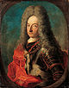 | 23 Jan 1719 - 11 Oct 1721 Anton Florian (s.a.)
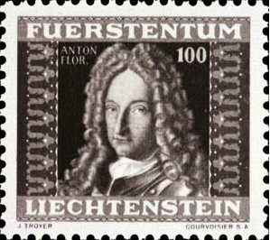
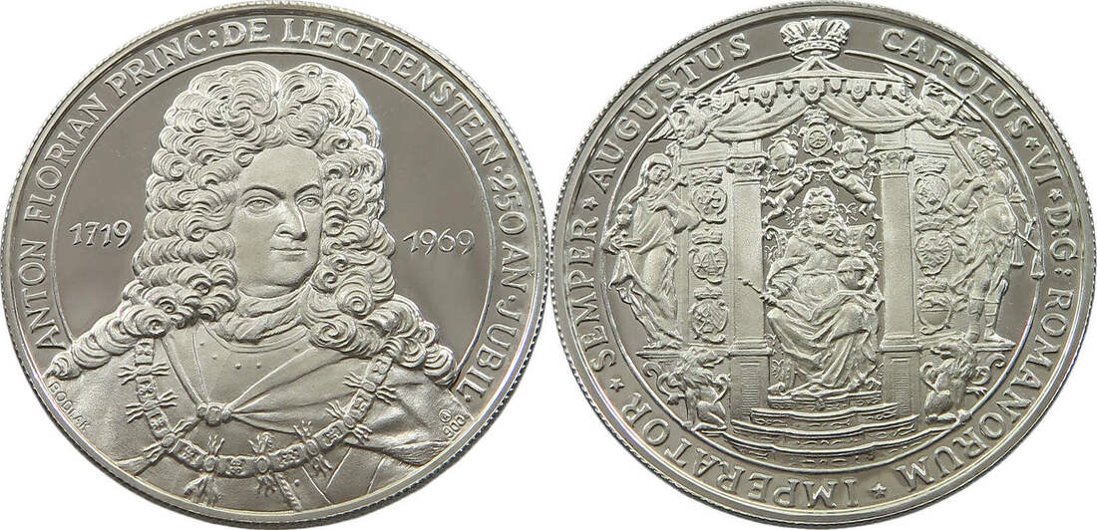
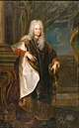 | 11 Oct 1721 - 17 Dec 1732 Joseph Johann Adam  (b. 1690 - d. 1732)
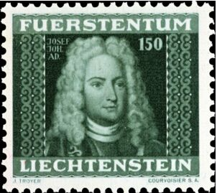 |  | 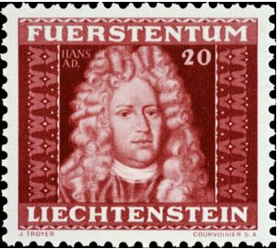
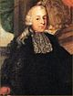 | 17 Dec 1732 - 22 Dec 1748 Johann Nepomuk Karl  (b. 1724 - d. 1748)
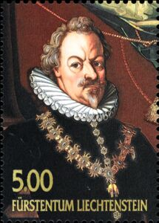
 | 17 Dec 1732 - 8 Jul 1745 Joseph Wenzel -Regent (s.a.)
 | 22 Dec 1748 - 10 Feb 1772 Joseph Wenzel (s.a.)
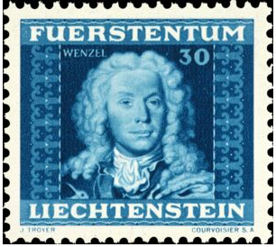
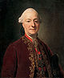 | 10 Feb 1772 - 18 Aug 1781 Franz Joseph I (b. 1726 - d. 1781)
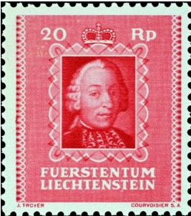 |  | 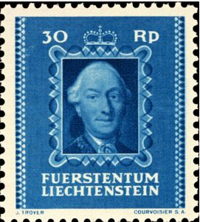
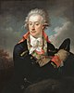 | 18 Aug 1781 - 24 Mar 1805 Aloys I (Alois I) (b. 1759 - d. 1805)
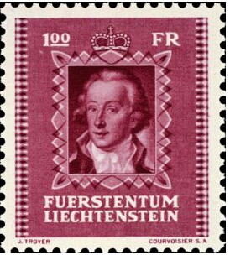
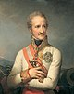 | 24 Mar 1805 - 1 Aug 1806 Johann I (1st time) (b. 1760 - d. 1836)
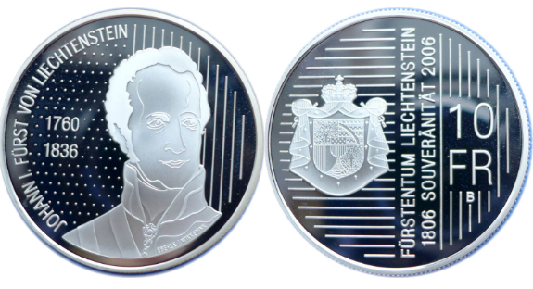
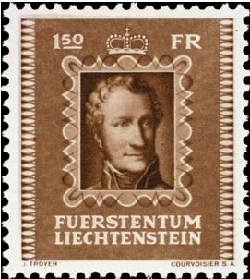 |  | 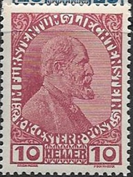
 | 1 Aug 1806 - 7 Dec 1813 Karl (b. 1803 - d. 1871)
 | 1 Aug 1806 - 7 Dec 1813 Johann I -Regent (s.a.)
 | 7 Dec 1813 - 20 Apr 1836 Johann I (2nd time) (s.a.)
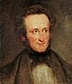 | 20 Apr 1836 - 12 Nov 1858 Alois II (b. 1796 - d. 1858)
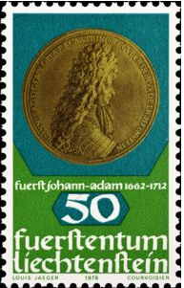 |  | 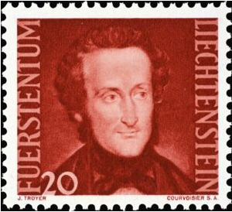
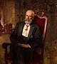 | 12 Nov 1858 - 11 Feb 1929 Johann II (b. 1840 - d. 1929)
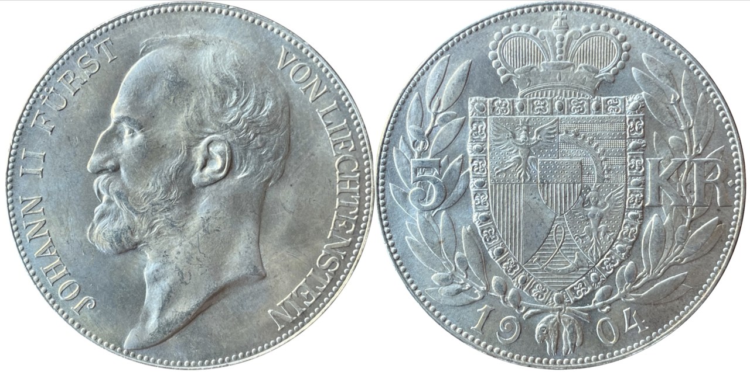
 |  | 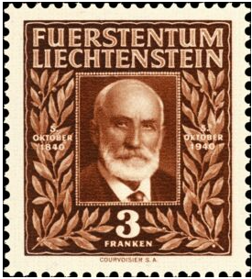
10 Feb 1859 - 9 Nov 1860 Franziska de Paula (f) -Regent
(b. 1813 - d. 1881)
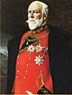 | 11 Feb 1929 - 25 Jul 1938 Franz (b. 1853 - d. 1938)
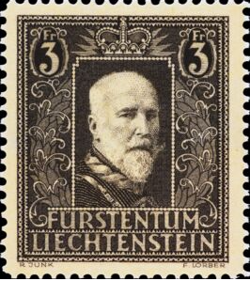
30 Mar 1938 - 25 Jul 1938 Prinz Franz Joseph -Regent
(b. 1906 - d. 1989)
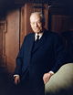 | 25 Jul 1938 - 13 Nov 1989 Franz Joseph II (s.a.)
 | 26 Aug 1984 - 13 Nov 1989 Hans-Adam -Regent (b. 1945)
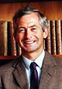 | 13 Nov 1989 - Hans-Adam II (Johannes Adam II) (s.a.)
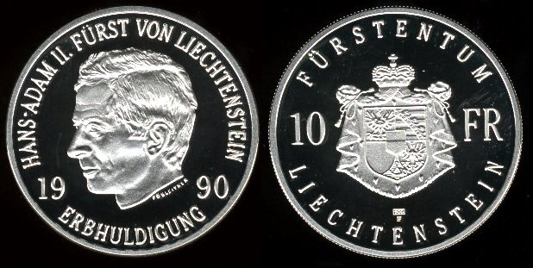
 | 15 Aug 2004 - Prinz Alois -Regent (b. 1968)
Landvögte zu Vaduz (Land Bailiffs)
1509 - 1513 Martin Steinhuser (Steinhauser)
1513 - 1515 Georg Kräler (vogt)
1515 - bf.1521 Hans von Pfin
bf.1522 - af.1534 Kaspar Mammendorfer (Mannendorfer)
1537 - 1538 Georg Vockh
1542 - 1543 Kaspar von Ulm
bf.1544 - 155. Franz Landtmann
bf.1552 - 158. Juvenal Kreder (b. 151. - d. 158.)
158. - 1592 Philibert Rignoldt von Prosswalden (b. c.1550 - d. 1616)
1592 - 1597 Peter Christoph Schlabatius (b. 1565? - d. 1619)
(Schlabaz)
1597 - 1613 Sigmund Rainolt (b. c.1545 - d. 1620)
1613 - 1619 Johann Othmar Haslach (b. c.1575 - d. 162.)
1619 - 1626 Johann Emmerich Rignoldt (Ringolt) (b. 15.. - d. af.1637)
von Prosswalden
1626 - 1646 Zacharias Furtenbach von (b. c.1587 - d. af.1664)
Schregenberg
1647 - 3 Oct 1654 Hans Jakob Sandholzer von (b. c.1600 - d.1654)
Zunderberg (Sonderberg)
1654 - 1657 Jakob Friedrich Pappus von (b. c.1604 - d. af.1659)
Tratzberg
1658 - 1662 Johann Jakob Harder (b. c.1620 - d. 16..)
1662 - 1676 Christoph Köberle (1st time) (b. 1629 - d. 1692)
1677 - 1679 Johann Matthias Christoph Bildstein(b. 1651 - d. 1714)
(Bildtstein)
1679 Christoph Köberle (2nd time) (s.a.)
(acting)
1679 - 1679 Johann Romarich Brügler von (b. c.1640 - d. 1696?)
Herkulesberg
1680 - 1683 Andreas Joseph Walser (b. 1635 - d. 1684)
1683 - 10 Jan 1692 Christoph Köberle (3rd time) (s.a.)
1692 - 5 Mar 1694 Leonhard Frey von Schönstein (b. c.1628 - d. 1694)
1695 - 1697 Bernhard (Franz) Abegg
1697 - 1699 Johann Franz Ziegler (b. c.1657 - d. 17..)
1699 - 1706 Johann Rudolf Gasser von (b. 1647 - d. 1714?)
Strassberg
1706 - 9 Jun 1712 Josef Anton Rohrer (b. 1662 - d.1721)
Fürstlicher Landvogt von Schellenberg
16 Mar 1699 - 9 Apr 1712 Johann Franz Paur (Bauer) (b. 1653? - d. 1715)
Fürstliche Landvögte von Liechtenstein (Princely Land Bailiffs)
9 Apr 1712 - 1715 Johann Franz Paur (Bauer) (s.a.)
1715 - 1719 Joseph Grentzing von Strassberg (b. 1666? - d. 1729)
1719 - 1720 Johann Adam Brändl (acting)
23 Apr 1720 - 20 Apr 1727 Johann Christoph von Bentz (b. 1673 - d. 1750)
(1st time)
20 Apr 1727 - 28 May 1730 Johann Erwin von Keil
28 May 1730 - 1 Oct 1730 Anton Bauer (1st time)(acting) (b. 169. - d. af.1749)
1 Oct 1730 - 12 Mar 1734 Franz Anton Keller (b. 1669? - d. 17..)
12 Mar 1734 - 30 Apr 1734 Anton Bauer (2nd time)(acting) (s.a.)
30 Apr 1734 - 11 Aug 1735 Johann Christoph von Bentz (s.a.)
(2nd time)(acting)
11 Aug 1735 - 4 Feb 1747 Anton Bauer (3rd time)(acting) (s.a.)
4 Feb 1747 - 1751 Johann Kaspar Laaba (b. 1722? - d. af.1756)
1751 - 1770 Franz Karl von Grillot
1770 - 1771 P. Gabriel Rheinhard (Reinhard) (b. 1711 - d. 1773)
(acting)
24 Oct 1771 - 8 Jun 1775 Ferdinand Anton Funkner von (b. c.1730 - d. 1775)
Funkenberg
8 Jun 1775 - 31 Aug 1775 Michel Franz Joseph Ambrosi (b. 172. - d. 1785)
(acting)
1 Sep 1775 - 20 Jan 1789 Franz Michael Heinrich Gilm von (b. 1737? - d. 1814)
Rosenegg
20 Jan 1789 - 1 Oct 1808 Franz Xaver Menzinger (b. 1740 - d. 1809)
1 Oct 1808 - 31 Jan 1827 Joseph Schuppler (b. 1776 - d. 1833)
1 Feb 1827 - 7 Sep 1833 Peter Pokorny (b. 1795 - d. 1866)
7 Sep 1833 - 12 Apr 1848 Johann Michael Menzinger (b. 1792 - d. 1877)
Princely Land Administrators (Fürstliche Landesverweser)
12 Apr 1848 - 3 Apr 1861 Johann Michael Menzinger (s.a.)
4 Apr 1861 - 24 Sep 1884 Karl Freiherr Haus von Hausen (b. 1823 - d. 1889) Non-party
24 Sep 1884 - 12 Sep 1892 Karl von In der Maur auf (b. 1852 - d. 1913) Non-party
Strehlburg (1st time)
12 Sep 1892 - 24 Oct 1896 Friedrich Stellwag von Carion (b. 1852 - d. 1896) Non-party
30 Oct 1896 - 11 Dec 1913 Karl von In der Maur auf (s.a.) Non-party
Strehlburg (2nd time)
11 Dec 1913 - 31 Mar 1914 Joseph Ospelt (acting) (b. 1881 - d. 1962) Non-party
1 Apr 1914 - 7 Nov 1918 Leopold Freiherr von Imhof (b. 1869 - d. 1922) Non-party
President of the Provisional Executive Committee
7 Nov 1918 - 13 Dec 1918 Martin Ritter (b. 1872 - d. 1947) Non-party
Princely Land Administrators (Fürstliche Landesverweser)
13 Dec 1918 - 28 Sep 1920 Prinz Karl Alois von und zu (b. 1878 - d. 1955) Non-party
Liechtenstein
28 Sep 1920 - 4 Apr 1921 Joseph Peer (b. 1864 - d. 1925) Non-party
23 Mar 1921 - 5 Oct 1921 Joseph Ospelt (s.a.) FBP
(acting [for Peer to 4 Apr 1921] to 14 Apr 1921)
Chiefs of Government (Fürstliche Regierungschefs)
5 Oct 1921 - 11 May 1922 Joseph Ospelt (s.a.) FBP
10 Mar 1922 - 16 Jun 1922 Alphons Feger (b. 1856 - d. 1933) Non-party
(acting [for Ospelt to 11 May 1922])
1 Jun 1922 - 16 Jun 1922 Felix Gubelmann (b. 1880 - d. 1929) FBP
(acting [for Feger to 16 Jun 1922])
16 Jun 1922 - 27 Jun 1928 Gustav Schädler (b. 1883 - d. 1961) CSV
27 Jun 1928 - 5 Aug 1928 Prinz Alfred von und zu (b. 1875 - d. 1930) Non-party
Liechtenstein (provisional)
5 Aug 1928 - 3 Sep 1945 Josef Hoop (b. 1895 - d. 1959) FBP
3 Sep 1945 - 16 Jul 1962 Alexander Frick (b. 1910 - d. 1991) FBP
16 Jul 1962 - 18 Mar 1970 Gerard Batliner (b. 1928 - d. 2008) FBP
18 Mar 1970 - 27 Mar 1974 Alfred Hilbe (b. 1928 - d. 2011) VU
27 Mar 1974 - 26 Apr 1978 Walter Kieber (b. 1931 - d. 2014) FBP
26 Apr 1978 - 26 May 1993 Hans Brunhart (b. 1945) VU
26 May 1993 - 15 Dec 1993 Markus Büchel (b. 1959 - d. 2013) FBP
15 Dec 1993 - 5 Apr 2001 Mario Frick (b. 1965) VU
5 Apr 2001 - 25 Mar 2009 Otmar Hasler (b. 1953) FBP
25 Mar 2009 - 27 Mar 2013 Klaus Tschütscher (b. 1967) VU
27 Mar 2013 - 25 Mar 2021 Adrian Hasler (b. 1964) FBP
25 Mar 2021 - Daniel Risch (b. 1978) VU
¹Date on which the territorial Principality of Liechtenstein received imperial recognition. The title Prince of Liechtenstein (derived not from the territory but from Liechtenstein Castle near Vienna) was granted earlier, but only as a personal distinction. It is from one of those earlier princes, Johann Adam I Andreas (s.a.), that the current prince derives his "II." The rulers of the Liechtenstein family lived mainly in Lower Austria and Moravia until moving permanently to Liechtenstein only in 1938.
²Full style of the rulers:
(a) 15 Apr 1613 - 9 Jun 1712 (Counts of Hohenems): Graff zu Hochenembs, Gallara und Vaduz, Herr zu Schellenberg, Dorenbüren und Lustnaw ("Count of Hohenems, Gallara and Vaduz, Lord of Schellenberg, Dorenbüren and Lustnaw");
(b) 16 Mar 1699 - 16 Jun 1712: Fürst und Regierer des Hauses von und zu Liechtenstein und von Nicolspurg, Hertzog zu Troppau und Jägerndorff in Schlesien, Graff zu Rittberg ("Prince and Governor of the House of and at Liechtenstein and of Nikolsburg, Duke of Troppau and Jägerndorf in Silesia, Count of Rietberg");
(b) 16 Jun 1712 - 5 Sep 1718: Fürst von und zu Liechtenstein und von Nicolspurg, Hertzog zu Troppau und Jägerndorff in Schlesien, Graff zu Rittberg ("Prince of and at Liechtenstein and of Nikolsburg, Duke of Troppau and Jägerndorf in Silesia, Count of Rittberg");
(c) 5 Sep 1718 - 1 Aug 1806: Fürst und Regierer des Hauses von und zu Liechtenstein und von Nicolspurg, Hertzog zu Troppau und Jägerndorff in Schlesien, Graff zu Rittberg ("Prince and Governor of the House of and at Liechtenstein and of Nikolsburg, Duke of Troppau and Jägerndorf in Silesia, Count of Rietberg");
(d) 1 Aug 1806 - 5 Oct 1862: Souveräner Fürst und Regierer des Hauses von und zu Liechtenstein und von Nikolsburg, Herzog zu Troppau und Jägerndorf in Schlesien, Graf zu Rittberg ("Sovereign Prince and Governor of the House of and at Liechtenstein and of Nikolsburg, Duke of Troppau and Jägerndorf, Count of Rietberg");
(e) 5 Oct 1862 - 5 Oct 1921: Souveräner Fürst und Regierer des Hauses von und zu Liechtenstein, Herzog zu Troppau und Jägerndorf, Graf zu Rietberg ("Sovereign Prince and Governor of the House of and at Liechtenstein, Duke of Troppau and Jägerndorf, Count of Rietberg");
(f) 5 Oct 1921 - 6 Dec 1993: Souveräner Fürst von und zu Liechtenstein ("Sovereign Prince of and in Liechtenstein);
(g) from 6 Dec 1993: Fürst von und zu Liechtenstein, Herzog von Troppau und Jägerndorf, Graf zu Rietberg, Regierer des Hauses von und zu Liechtenstein ("Prince of Liechtenstein, Duke of Troppau and Jägerndorf, Count of Rietberg, Governor of the House of and at Liechtenstein").
Territorial Dispute: None; in Feb. 2005, the ICJ refused to rule on the restitution of the prince of Liechtenstein's land and property assets in the Czech Republic confiscated in 1945 as German property.
Party abbreviations: FBP = Fortschrittliche Bürgerpartei in Liechtenstein (Progressive Citizens' Party in Liechtenstein, centrist, christian-democratic, est.22 Dec 1918); VU = Vaterländische Union (Fatherland Union, christian democratic, est.5 Jan 1936);
- Former parties: CSV = Christlich-soziale Volkspartei (Christian Social People's Party, conservative, 1918-5 Jan 1936, merged into VU); VDBL = Volksdeutsche Bewegung in Liechtenstein (German National Movement in Liechtenstein, national socialist, supported union with Germany, Mar 1938-1945)

INCLUDEPICTURE "http://t0.gstatic.com/images?q=tbn:ANd9GcTDT1jpfS6n_Y4NmsXFnf0dV2uAk854tEHeOSaIXPxUCt7qxHu5xaSaZA" \* MERGEFORMATINET INCLUDEPICTURE "http://t0.gstatic.com/images?q=tbn:ANd9GcTDT1jpfS6n_Y4NmsXFnf0dV2uAk854tEHeOSaIXPxUCt7qxHu5xaSaZA" \* MERGEFORMATINET INCLUDEPICTURE "http://t0.gstatic.com/images?q=tbn:ANd9GcTDT1jpfS6n_Y4NmsXFnf0dV2uAk854tEHeOSaIXPxUCt7qxHu5xaSaZA" \* MERGEFORMATINET INCLUDEPICTURE "http://t0.gstatic.com/images?q=tbn:ANd9GcTDT1jpfS6n_Y4NmsXFnf0dV2uAk854tEHeOSaIXPxUCt7qxHu5xaSaZA" \* MERGEFORMATINET INCLUDEPICTURE "http://t0.gstatic.com/images?q=tbn:ANd9GcTDT1jpfS6n_Y4NmsXFnf0dV2uAk854tEHeOSaIXPxUCt7qxHu5xaSaZA" \* MERGEFORMATINET INCLUDEPICTURE "http://t0.gstatic.com/images?q=tbn:ANd9GcTDT1jpfS6n_Y4NmsXFnf0dV2uAk854tEHeOSaIXPxUCt7qxHu5xaSaZA" \* MERGEFORMATINET INCLUDEPICTURE "http://t0.gstatic.com/images?q=tbn:ANd9GcTDT1jpfS6n_Y4NmsXFnf0dV2uAk854tEHeOSaIXPxUCt7qxHu5xaSaZA" \* MERGEFORMATINET INCLUDEPICTURE "http://t0.gstatic.com/images?q=tbn:ANd9GcTDT1jpfS6n_Y4NmsXFnf0dV2uAk854tEHeOSaIXPxUCt7qxHu5xaSaZA" \* MERGEFORMATINET INCLUDEPICTURE "http://t0.gstatic.com/images?q=tbn:ANd9GcTDT1jpfS6n_Y4NmsXFnf0dV2uAk854tEHeOSaIXPxUCt7qxHu5xaSaZA" \* MERGEFORMATINET INCLUDEPICTURE "http://t0.gstatic.com/images?q=tbn:ANd9GcTDT1jpfS6n_Y4NmsXFnf0dV2uAk854tEHeOSaIXPxUCt7qxHu5xaSaZA" \* MERGEFORMATINET INCLUDEPICTURE "http://t0.gstatic.com/images?q=tbn:ANd9GcTDT1jpfS6n_Y4NmsXFnf0dV2uAk854tEHeOSaIXPxUCt7qxHu5xaSaZA" \* MERGEFORMATINET INCLUDEPICTURE "http://t0.gstatic.com/images?q=tbn:ANd9GcTDT1jpfS6n_Y4NmsXFnf0dV2uAk854tEHeOSaIXPxUCt7qxHu5xaSaZA" \* MERGEFORMATINET INCLUDEPICTURE "http://t0.gstatic.com/images?q=tbn:ANd9GcTDT1jpfS6n_Y4NmsXFnf0dV2uAk854tEHeOSaIXPxUCt7qxHu5xaSaZA" \* MERGEFORMATINET INCLUDEPICTURE "http://t0.gstatic.com/images?q=tbn:ANd9GcTDT1jpfS6n_Y4NmsXFnf0dV2uAk854tEHeOSaIXPxUCt7qxHu5xaSaZA" \* MERGEFORMATINET INCLUDEPICTURE "http://t0.gstatic.com/images?q=tbn:ANd9GcTDT1jpfS6n_Y4NmsXFnf0dV2uAk854tEHeOSaIXPxUCt7qxHu5xaSaZA" \* MERGEFORMATINET INCLUDEPICTURE "http://t0.gstatic.com/images?q=tbn:ANd9GcTDT1jpfS6n_Y4NmsXFnf0dV2uAk854tEHeOSaIXPxUCt7qxHu5xaSaZA" \* MERGEFORMATINET INCLUDEPICTURE "http://t0.gstatic.com/images?q=tbn:ANd9GcTDT1jpfS6n_Y4NmsXFnf0dV2uAk854tEHeOSaIXPxUCt7qxHu5xaSaZA" \* MERGEFORMATINET INCLUDEPICTURE "http://t0.gstatic.com/images?q=tbn:ANd9GcTDT1jpfS6n_Y4NmsXFnf0dV2uAk854tEHeOSaIXPxUCt7qxHu5xaSaZA" \* MERGEFORMATINET INCLUDEPICTURE "http://t0.gstatic.com/images?q=tbn:ANd9GcTDT1jpfS6n_Y4NmsXFnf0dV2uAk854tEHeOSaIXPxUCt7qxHu5xaSaZA" \* MERGEFORMATINET INCLUDEPICTURE "http://t0.gstatic.com/images?q=tbn:ANd9GcTDT1jpfS6n_Y4NmsXFnf0dV2uAk854tEHeOSaIXPxUCt7qxHu5xaSaZA" \* MERGEFORMATINET INCLUDEPICTURE "http://t0.gstatic.com/images?q=tbn:ANd9GcTDT1jpfS6n_Y4NmsXFnf0dV2uAk854tEHeOSaIXPxUCt7qxHu5xaSaZA" \* MERGEFORMATINET INCLUDEPICTURE "http://t0.gstatic.com/images?q=tbn:ANd9GcTDT1jpfS6n_Y4NmsXFnf0dV2uAk854tEHeOSaIXPxUCt7qxHu5xaSaZA" \* MERGEFORMATINET INCLUDEPICTURE "http://t0.gstatic.com/images?q=tbn:ANd9GcTDT1jpfS6n_Y4NmsXFnf0dV2uAk854tEHeOSaIXPxUCt7qxHu5xaSaZA" \* MERGEFORMATINET INCLUDEPICTURE "http://t0.gstatic.com/images?q=tbn:ANd9GcTDT1jpfS6n_Y4NmsXFnf0dV2uAk854tEHeOSaIXPxUCt7qxHu5xaSaZA" \* MERGEFORMATINET INCLUDEPICTURE "http://t0.gstatic.com/images?q=tbn:ANd9GcTDT1jpfS6n_Y4NmsXFnf0dV2uAk854tEHeOSaIXPxUCt7qxHu5xaSaZA" \* MERGEFORMATINET INCLUDEPICTURE "http://t0.gstatic.com/images?q=tbn:ANd9GcTDT1jpfS6n_Y4NmsXFnf0dV2uAk854tEHeOSaIXPxUCt7qxHu5xaSaZA" \* MERGEFORMATINET INCLUDEPICTURE "http://t0.gstatic.com/images?q=tbn:ANd9GcTDT1jpfS6n_Y4NmsXFnf0dV2uAk854tEHeOSaIXPxUCt7qxHu5xaSaZA" \* MERGEFORMATINET INCLUDEPICTURE "http://t0.gstatic.com/images?q=tbn:ANd9GcTDT1jpfS6n_Y4NmsXFnf0dV2uAk854tEHeOSaIXPxUCt7qxHu5xaSaZA" \* MERGEFORMATINET INCLUDEPICTURE "http://t0.gstatic.com/images?q=tbn:ANd9GcTDT1jpfS6n_Y4NmsXFnf0dV2uAk854tEHeOSaIXPxUCt7qxHu5xaSaZA" \* MERGEFORMATINET INCLUDEPICTURE "http://t0.gstatic.com/images?q=tbn:ANd9GcTDT1jpfS6n_Y4NmsXFnf0dV2uAk854tEHeOSaIXPxUCt7qxHu5xaSaZA" \* MERGEFORMATINET INCLUDEPICTURE "http://t0.gstatic.com/images?q=tbn:ANd9GcTDT1jpfS6n_Y4NmsXFnf0dV2uAk854tEHeOSaIXPxUCt7qxHu5xaSaZA" \* MERGEFORMATINET INCLUDEPICTURE "http://t0.gstatic.com/images?q=tbn:ANd9GcTDT1jpfS6n_Y4NmsXFnf0dV2uAk854tEHeOSaIXPxUCt7qxHu5xaSaZA" \* MERGEFORMATINET INCLUDEPICTURE "http://t0.gstatic.com/images?q=tbn:ANd9GcTDT1jpfS6n_Y4NmsXFnf0dV2uAk854tEHeOSaIXPxUCt7qxHu5xaSaZA" \* MERGEFORMATINET INCLUDEPICTURE "http://t0.gstatic.com/images?q=tbn:ANd9GcTDT1jpfS6n_Y4NmsXFnf0dV2uAk854tEHeOSaIXPxUCt7qxHu5xaSaZA" \* MERGEFORMATINET INCLUDEPICTURE "http://t0.gstatic.com/images?q=tbn:ANd9GcTDT1jpfS6n_Y4NmsXFnf0dV2uAk854tEHeOSaIXPxUCt7qxHu5xaSaZA" \* MERGEFORMATINET INCLUDEPICTURE "http://t0.gstatic.com/images?q=tbn:ANd9GcTDT1jpfS6n_Y4NmsXFnf0dV2uAk854tEHeOSaIXPxUCt7qxHu5xaSaZA" \* MERGEFORMATINET INCLUDEPICTURE "http://t0.gstatic.com/images?q=tbn:ANd9GcTDT1jpfS6n_Y4NmsXFnf0dV2uAk854tEHeOSaIXPxUCt7qxHu5xaSaZA" \* MERGEFORMATINET INCLUDEPICTURE "http://t0.gstatic.com/images?q=tbn:ANd9GcTDT1jpfS6n_Y4NmsXFnf0dV2uAk854tEHeOSaIXPxUCt7qxHu5xaSaZA" \* MERGEFORMATINET INCLUDEPICTURE "http://t0.gstatic.com/images?q=tbn:ANd9GcTDT1jpfS6n_Y4NmsXFnf0dV2uAk854tEHeOSaIXPxUCt7qxHu5xaSaZA" \* MERGEFORMATINET INCLUDEPICTURE "http://t0.gstatic.com/images?q=tbn:ANd9GcTDT1jpfS6n_Y4NmsXFnf0dV2uAk854tEHeOSaIXPxUCt7qxHu5xaSaZA" \* MERGEFORMATINET INCLUDEPICTURE "http://t0.gstatic.com/images?q=tbn:ANd9GcTDT1jpfS6n_Y4NmsXFnf0dV2uAk854tEHeOSaIXPxUCt7qxHu5xaSaZA" \* MERGEFORMATINET INCLUDEPICTURE "http://t0.gstatic.com/images?q=tbn:ANd9GcTDT1jpfS6n_Y4NmsXFnf0dV2uAk854tEHeOSaIXPxUCt7qxHu5xaSaZA" \* MERGEFORMATINET INCLUDEPICTURE "http://t0.gstatic.com/images?q=tbn:ANd9GcTDT1jpfS6n_Y4NmsXFnf0dV2uAk854tEHeOSaIXPxUCt7qxHu5xaSaZA" \* MERGEFORMATINET

Compiler FLN

